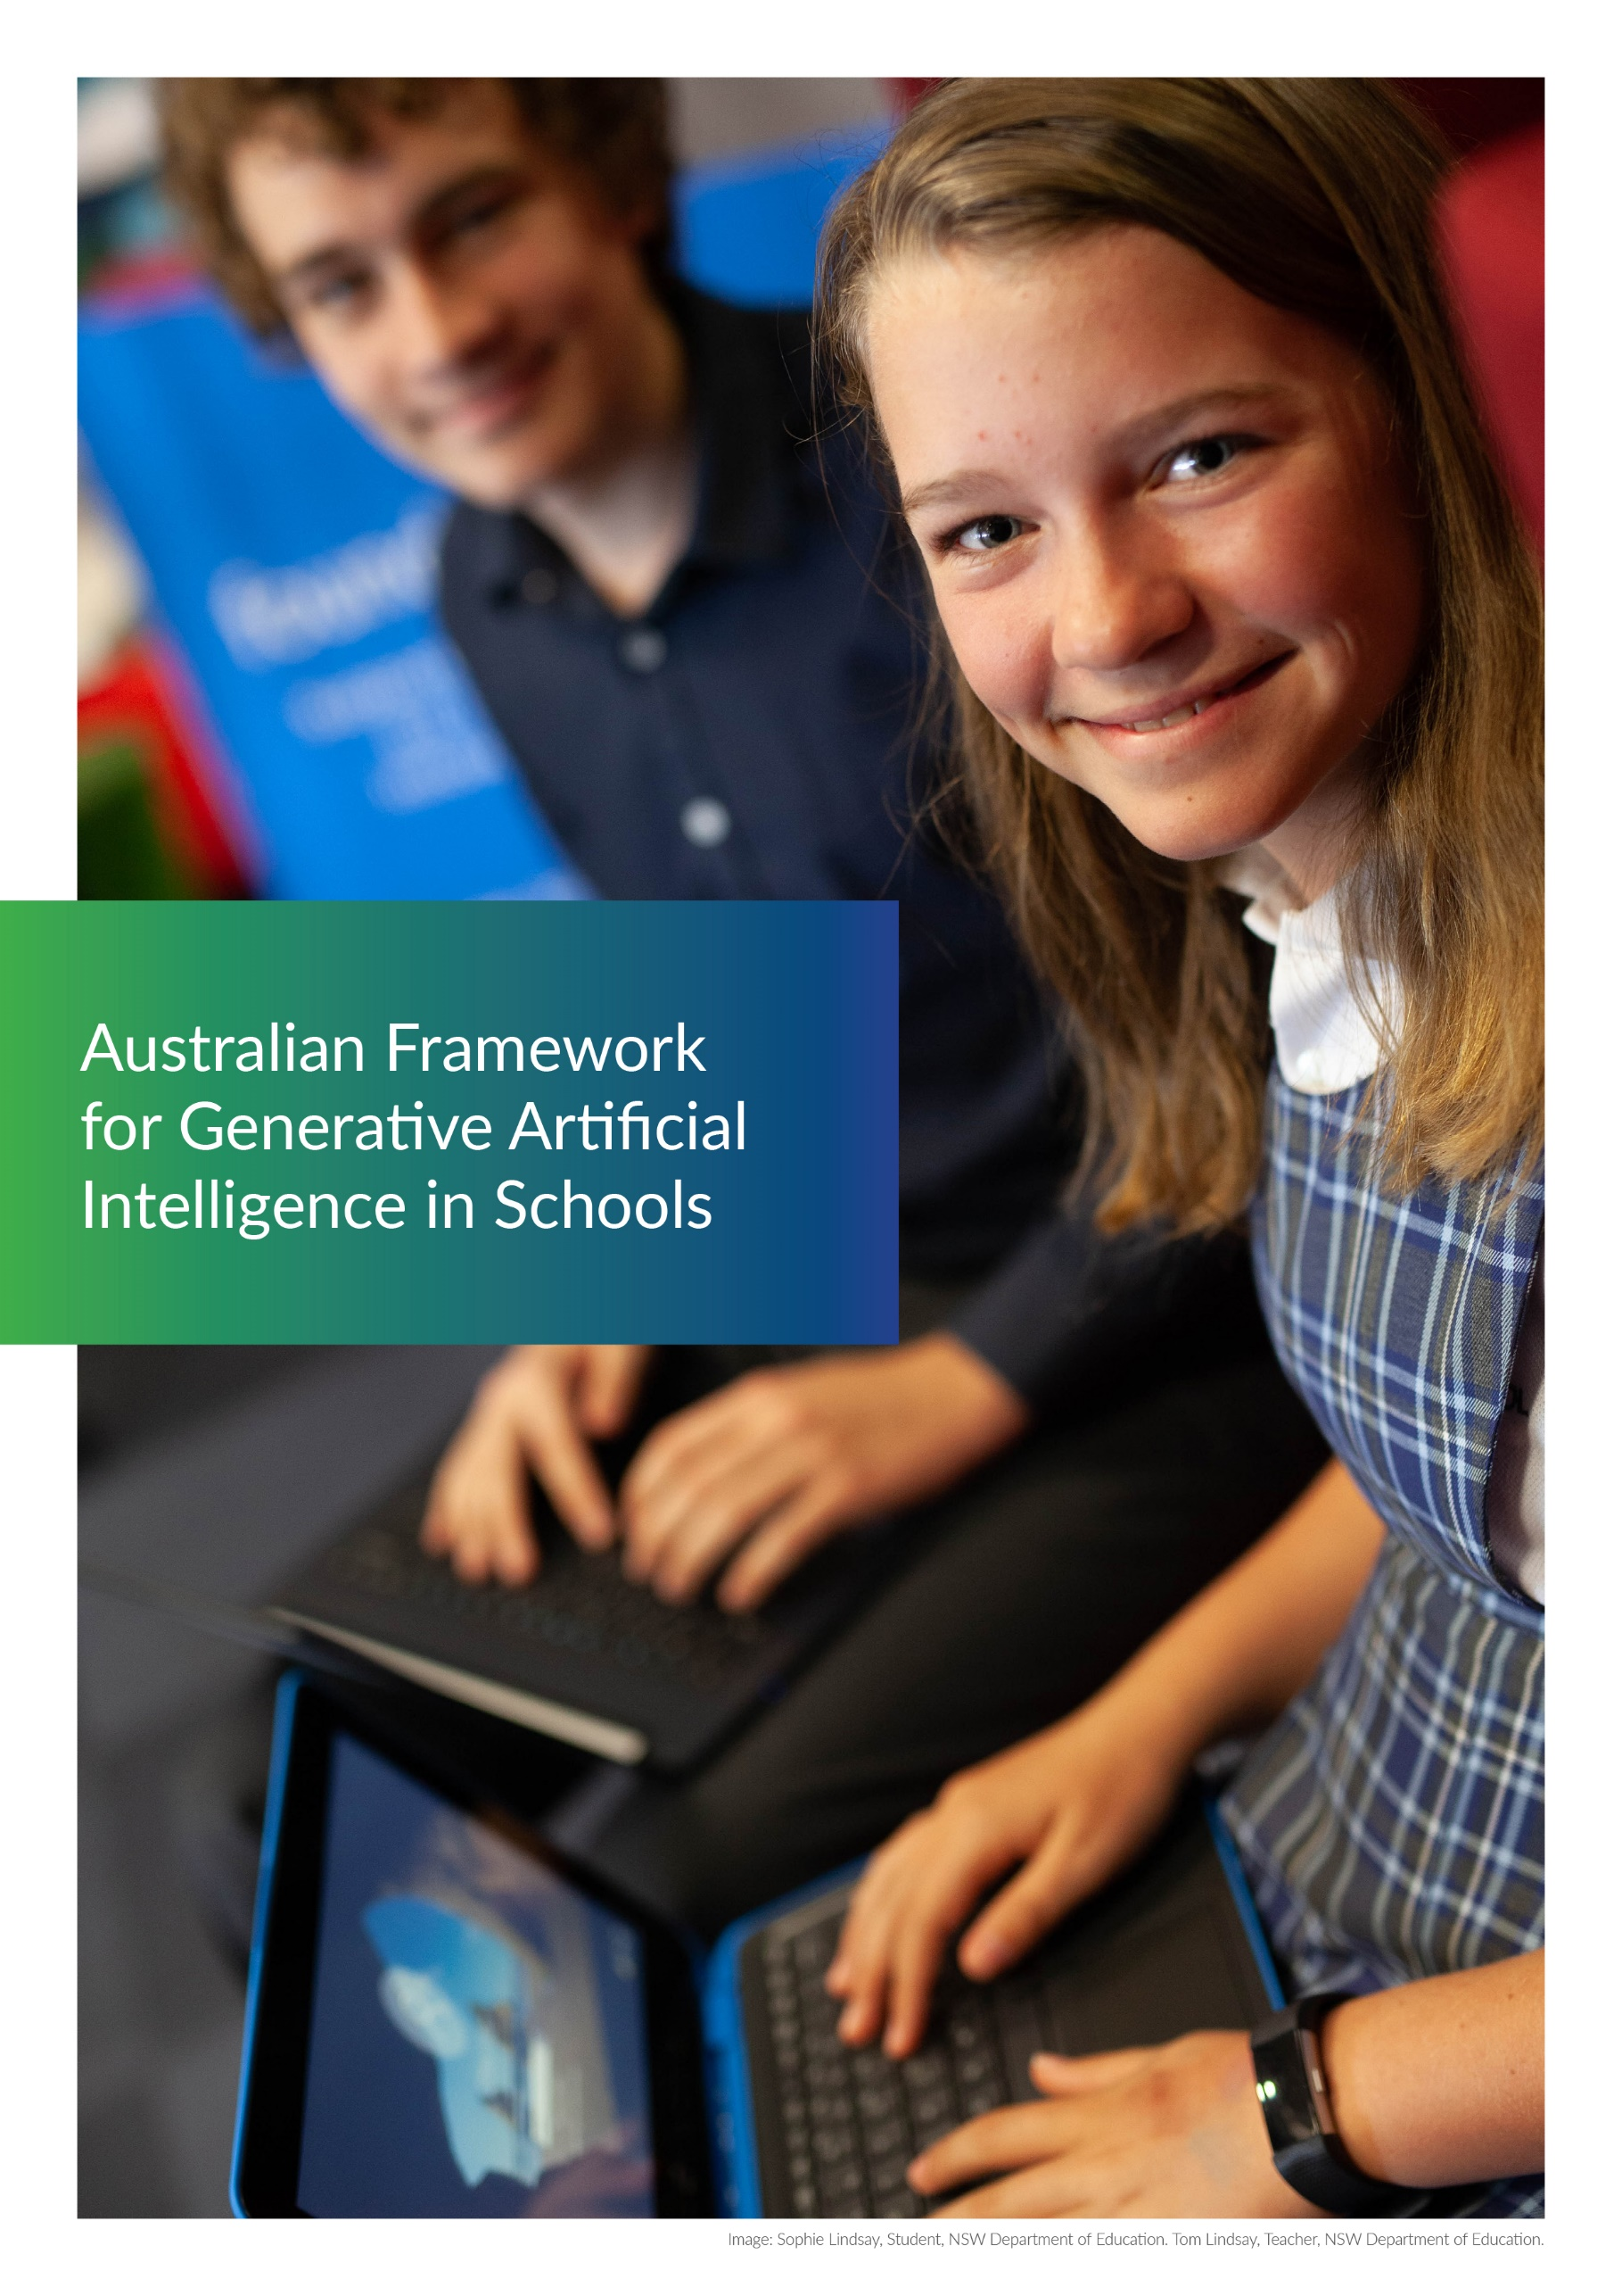

# Australian Framework for Generative Artificial Intelligence in Schools



## Acknowledgement of Country

The National AI in Schools Taskforce recognises and pays respect to the Traditional Custodians of the lands and waterways where we work and live. We celebrate Aboriginal and Torres Strait Islander people’s unique cultural and spiritual relationship to Country and acknowledge the significance of their cultures in Australia.

© Commonwealth of Australia, 2023.

Licensed under a Creative Commons Attribution 4.0 International (CC BY 4.0) licence.

[This is a Creative Commons 4.0 copyright license icon. Click it to be taken to the Creative Commons website.](https://creativecommons.org/licenses/by/4.0/?ref=chooser-v1)

Attribution should be given to:

© Commonwealth of Australia, 2023.

Material in this Framework not available under a Creative Commons licence includes the logos of the:

* Commonwealth of Australia, and the other jurisdictions (QLD, VIC, SA, WA, TAS, ACT, NT and NSW)
* national education agencies (ACARA, AERO, AITSL and ESA)
* non-government school sector peak bodies (ISA and NCEC).

## Acknowledgements

Members of the National AI in Schools Taskforce included representatives from all jurisdictions, the National Copyright Unit (NCU), non-government school sector peak bodies, Independent Schools Australia (ISA) and the National Catholic Education Commission (NCEC), and representatives from national education organisations, including the Australian Curriculum, Assessment and Reporting Authority (ACARA), the Australian Education Research Organisation (AERO), the Australian Institute for Teaching and School Leadership (AITSL) and Education Services Australia (ESA), with secretariat support provided by the NSW Department of Education.

The Taskforce acknowledges and thanks the academic community for providing insights on how to develop and improve the framework, with special thanks to: Professor Kalervo Gulson, Associate Professor Jason Lodge, Professor Terry Flew, Professor Toby Walsh, Professor Matt Bower, Associate Professor Christine Slade, Associate Professor Erica Southgate, Professor Michael Henderson, Industry Professor Ian Oppermann and Industry Professor Leslie Loble.

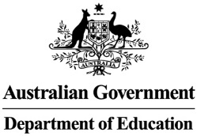

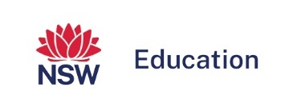



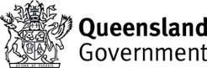

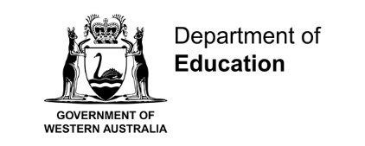



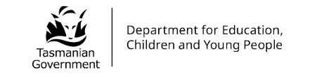

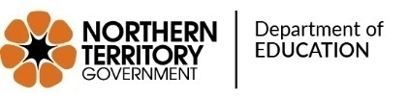

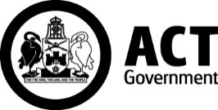

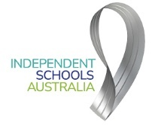



Australian Curriculum, Assessment and Reporting Authority logo.



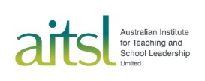



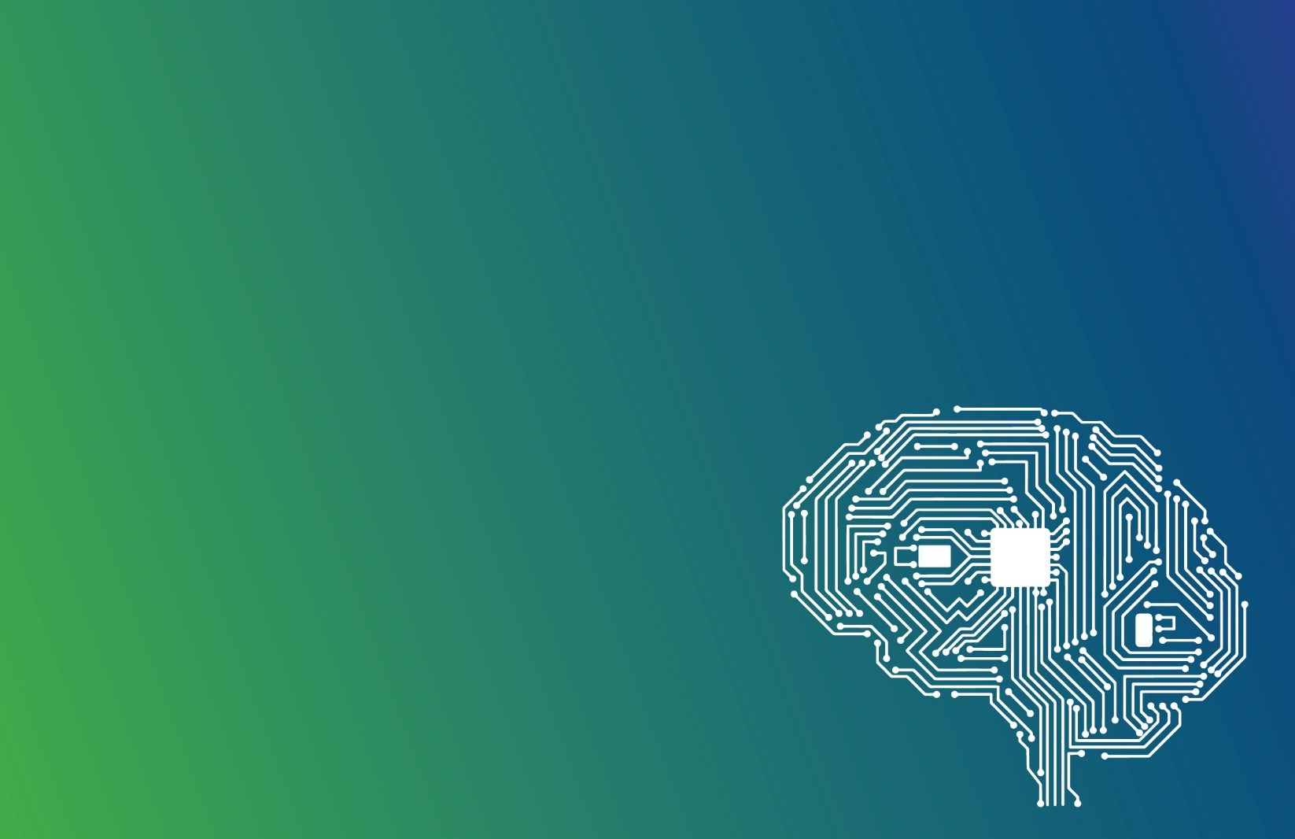The Australian Framework for Generative Artificial Intelligence (AI) in Schools (the Framework) seeks to guide the responsible and ethical use of generative AI tools in ways that benefit students, schools and society.

## What is Generative AI?

Generative AI can generate new content such as text, images, audio, and video that resembles what humans can produce. It is effective at recognising patterns (in video, audio, text or images) and emulating them when tasked with producing something.

## Purpose and Audience

The purpose of the Framework is to provide guidance on understanding, using and responding to generative AI in Australian school‑based education. It supports policy makers, school leaders, teachers, support staff, parents and students. It does not address other forms of artificial intelligence, including predictive AI.

The Framework is aspirational in nature, defining what safe, ethical and responsible use of generative AI should look like to support better school outcomes. The Framework’s Principles and Guiding Statements are designed to help jurisdictions and sectors align existing approaches while also supporting the development of future work.

## Design of the Framework

The Framework is designed to help Australian school communities (students, teachers, staff, parents and carers) support:

* Education outcomes: The Framework aims to recognise how the appropriate use of generative AI tools can enhance teaching and learning outcomes for all members of Australian school communities.
* Ethical practices: The Framework aims to achieve the safe, responsible and ethical use of generative AI tools in Australian schools.
* Equity and inclusion: The Framework aims to ensure that generative AI tools are used in ways that are fair, accessible and inclusive of all Australian school communities.

These goals are the basis of the Framework’s 6 Principles and 25 Guiding Statements. Figure 1 provides a high-level illustration of the Framework, highlighting the interconnectedness of the Principles.

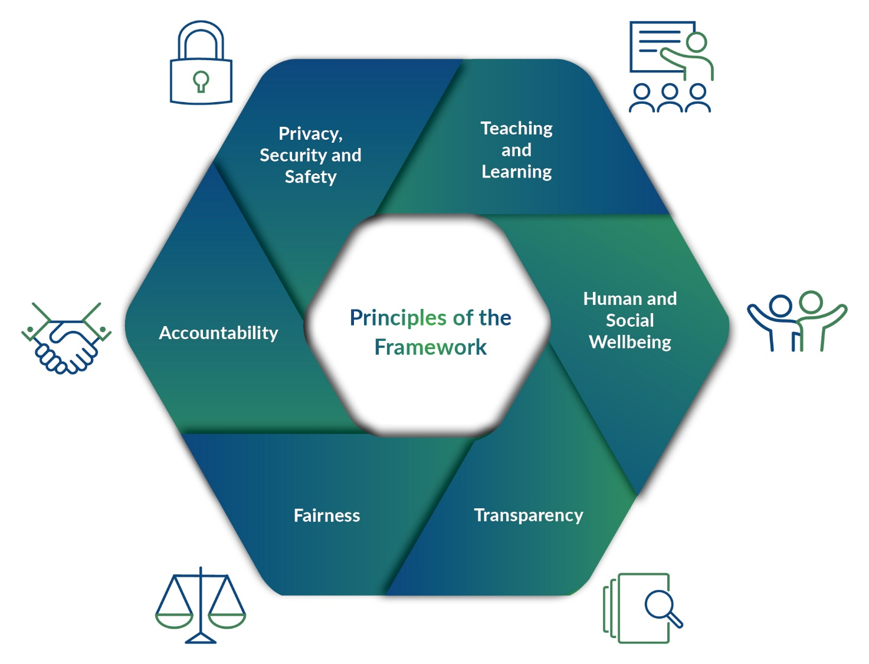

Figure 1: Visualisation of Australian Framework for Generative AI in Schools

## Opportunities and Risks

Generative AI technology has great potential to assist teaching and learning and reduce administrative workload in Australian schools. The growing accessibility and sophistication of generative AI tools provides opportunities to develop human-like generated text and rich multimedia content in a way that has not previously been possible.

To fully harness the potential of high quality and safe generative AI, schools will need to be supported in understanding and appropriately managing a range of privacy, security and ethical considerations. Risk management should also be appropriate for the potential consequences. These consequences include the potential for errors and algorithmic bias in generative AI content; the misuse of personal or confidential information; and the use of generative AI for inappropriate purposes, such as to discriminate against individuals or groups, or to undermine the integrity of student assessments. Appropriate and proportionate risk management will require robust guidance and policy, which the Framework aims to support.

About the Framework

In February 2023, Education Ministers agreed that responding to the risks and harnessing opportunities for Australian schools and students arising from generative AI technologies is a national education priority. Ministers agreed to develop an evidence-informed, best practice framework for Australian schools.

The Framework was developed in consultation with unions, teachers, students, industry, academics, and parent and school representative bodies from all sectors. It was developed by the National AI in Schools Taskforce comprised of representatives from all jurisdictions, school sectors, and the national agencies - Educational Services Australia (ESA), Australian Curriculum, Assessment and Reporting Authority (ACARA), Australian Institute for Teaching and School Leadership (AITSL), and Australian Education Research Organisation (AERO).

The Framework aligns to existing national policies and goals. It complements [Australia’s Artificial Intelligence Ethics Framework](https://www.industry.gov.au/publications/australias-artificial-intelligence-ethics-framework), and the two key goals of [The Alice Springs (Mparntwe) Education Declaration](https://www.education.gov.au/alice-springs-mparntwe-education-declaration): promoting equity and excellence in education; and enabling all young Australians to become confident and creative individuals, successful lifelong learners, and active and informed members of the community. Additionally, the Framework aligns to the [United Nations sustainable development goal #4](https://sdgs.un.org/goals/goal4): Ensure inclusive and equitable quality education and promote lifelong learning opportunities for all. It also aligns with the [Safer Technologies for Schools (ST4S)](https://st4s.edu.au/) initiative which aims to enhance the security, privacy and online safety of software services and applications commonly used in Australian schools.

Any policy development or amendments made to align with the Framework should also consider the [Australian Professional Standards for Teachers (APST)](https://www.aitsl.edu.au/standards), [Privacy Act 1988](https://www.legislation.gov.au/Details/C2023C00347), [Copyright Act 1968](https://www.legislation.gov.au/Details/C2022C00192), the [eSafety Commissioner’s Best Practice Framework for Online Safety Education](https://www.esafety.gov.au/educators/best-practice-framework), and Australia’s human rights protections. Where applicable, policies developed in alignment with the Framework must also meet existing government commitments to incorporate Indigenous community partnerships and expert reviews. Policies must also meet government obligations to ensure Indigenous communities have access to locally relevant data and information as per [Closing the Gap Priority Reform 4](https://www.closingthegap.gov.au/national-agreement/national-agreement-closing-the-gap/6-priority-reform-areas/four).

Review

The Framework will be reviewed by Education Ministers within 12 months of publication and every 12 months thereafter to accommodate the fast-moving pace of technological development in generative AI. Education Ministers may determine to review the Framework more frequently at their discretion.

## Australian Framework for Generative Artificial Intelligence in Schools

| Principles | Guiding Statements |
| --- | --- |
| Teaching and Learning  Generative AI tools are used to support and enhance teaching and learning. | **Impact:** generative AI tools are used in ways that enhance and support teaching, school administration, and student learning.  **Instruction:** schools engage students in learning about generative AI tools and how they work, including their potential limitations and biases, and deepen this learning as student usage increases.  **Teacher expertise:** generative AI tools are used in ways that support teacher expertise, and teachers are recognised and respected as the subject matter experts within the classroom.  **Critical thinking:** generative AI tools are used in ways that support and enhance critical thinking and creativity, rather than restrict human thought and experience.  **Learning design:** work designed for students, including assessments, clearly outlines how generative AI tools should or should not be used and allows for a clear and unbiased evaluation of student ability.  **Academic integrity:** students are supported to use generative AI tools ethically in their schoolwork, including by ensuring appropriate attribution. |
| Human and Social Wellbeing  Generative AI tools are used to benefit all members of the school community. | **Wellbeing:** generative AI tools are used in ways that do not harm the wellbeing and safety of any member of the school community.  **Diversity of perspectives:** generative AI tools are used in ways that expose users to diverse ideas and perspectives and avoid the reinforcement of biases.  **Human rights:** generative AI tools are used in ways that respect human and worker rights, including individual autonomy and dignity. |
| Transparency  School communities understand how generative AI tools work, how they can be used, and when and how these tools are impacting them. | **Information and support:** teachers, students, staff, parents and carers have access to clear and appropriate information and guidance about generative AI.  **Disclosure:** school communities are appropriately informed when generative AI tools are used in ways that impact them.  **Explainability:** vendors ensure that end users broadly understand the methods used by generative AI tools and their potential biases. |
| Fairness  Generative AI tools are used in ways that are accessible, fair, and respectful. | **Accessibility and inclusivity:** generative AI tools are used in ways that enhance opportunities, and are inclusive, accessible, and equitable for people with disability and from diverse backgrounds.  **Equity and access:** regional, rural and remote communities are considered when implementing generative AI.  **Non-discrimination:** generative AI tools are used in ways that support inclusivity, minimising opportunities for, and countering, unfair discrimination against individuals, communities, or groups.  **Cultural and intellectual property:** generative AI tools are used in ways that respect the cultural rights of various cultural groups, including Indigenous Cultural and Intellectual Property (ICIP) rights. |
| Accountability  Generative AI tools are used in ways that are open to challenge and retain human agency and accountability for decisions. | **Human responsibility:** teachers and school leaders retain control of decision making and remain accountable for decisions that are supported by the use of generative AI tools.  **Reliability:** generative AI tools are tested before they are used, and reliably operate in accordance with their intended purpose.  **Monitoring:** the impact of generative AI tools on school communities is actively and regularly monitored, and emerging risks and opportunities are identified and managed.  **Contestability:** members of school communities that are impacted by generative AI tools are actively informed about, and have opportunities to question, the use or outputs of the tools and any decisions informed by the tools. |
| Privacy, Security and Safety  Students and others using generative AI tools have their privacy and data protected. | **Privacy and data protection:** generative AI tools are used in ways that respect and uphold privacy and data rights, comply with Australian law, and avoid the unnecessary collection, limit the retention, prevent further distribution, and prohibit the sale of student data.  **Privacy disclosure:** school communities are proactively informed about how and what data will be collected, used, and shared while using generative AI tools, and consent is sought where needed.  **Protection of student inputs:** students, teachers and staff take appropriate care when entering information into generative AI tools which may compromise any individual’s data privacy.  **Cyber-security and resilience:** robust cyber-security measures are implemented to protect the integrity and availability of school infrastructure, generative AI tools, and associated data.  **Copyright compliance:** when using generative AI tools, schools are aware of, and take measures to comply with, applicable copyright rights and obligations. |